HCLTech Interview Questions
Ques 1). Identify the customer with the most recent transaction date.
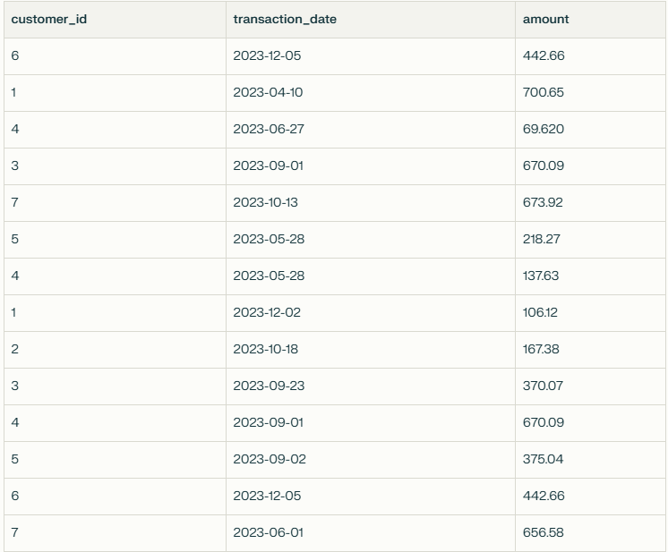

Ques 2). List each provider’s ID, total orders, number of late deliveries (delivered more than 2 days after order), and late delivery percentage.
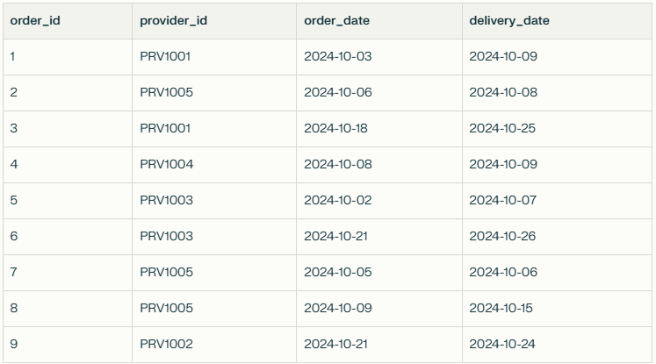

Sample Output (The numbers in the sample are for illustration only):
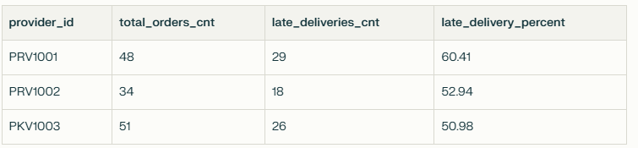
Ques 3). How many records will you get for each type of SQL join: INNER JOIN, LEFT JOIN, RIGHT JOIN, FULL JOIN, and CROSS JOIN?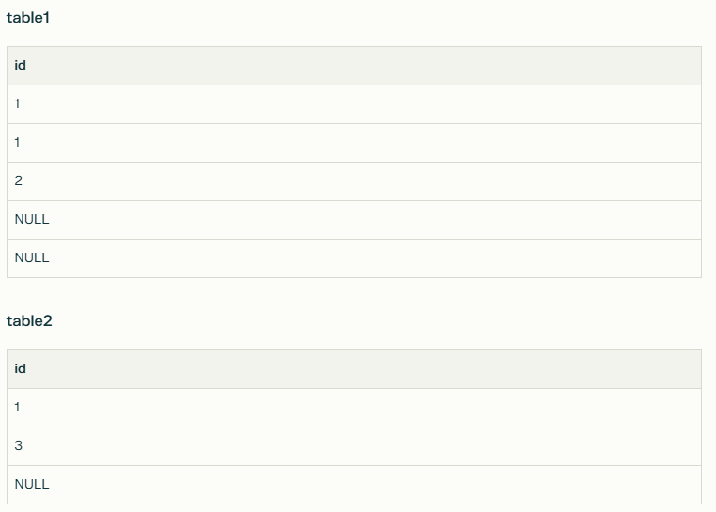

Ques 4). Find the possible combination pair of students
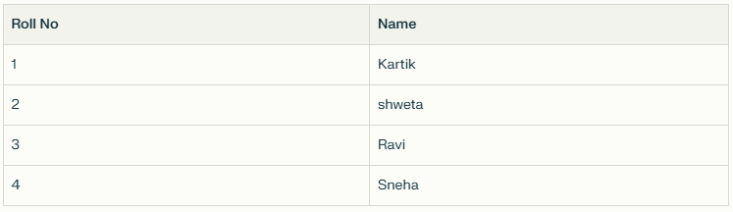
Output:
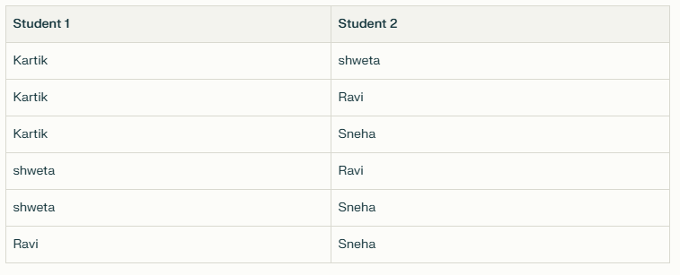
Ques 5). Find customers who have booked both Business and Economy travel types. 